Unit-1: Analytical Assignment with SDGs
Name: S.Sri Sai Prasanna Durga
Reg No: 192424241
Course Code: ITA0601-Machine Learning
Title: Machine Learning to Reduce Food Wastage in Supermarkets
Related Sustainable Development Goal (SDG)
SDG 2 – Zero Hunger
1.Problem Statement & SDG 2 – Zero Hunger:
1.1 Problem Statement:
Food wastage is a significant problem in supermarkets due to overstocking, inaccurate demand forecasting, and expiration of perishable products. Every day, supermarkets discard large quantities of food such as fruits, vegetables, dairy products, and bakery items because they remain unsold before their expiry dates. This results in financial losses, unnecessary use of natural resources, and reduced food availability for people.
Machine Learning provides an effective solution to this problem by analyzing historical sales data, customer purchasing behavior, and inventory information to predict future demand. Accurate demand prediction helps supermarkets stock the right quantity of products, reducing food wastage while improving operational efficiency and profitability.

1.2 Sustainable Development Goal (SDG 2 – Zero Hunger):
Objective:
The objective of SDG 2 – Zero Hunger is to end hunger, achieve food security, improve nutrition, and promote sustainable agriculture. The goal encourages efficient use of food resources so that less food is wasted and more food becomes available to people.
Relation of the Project to SDG 2:
This project directly supports SDG 2 – Zero Hunger by reducing food wastage in supermarkets through Machine Learning. By predicting customer demand accurately, supermarkets can avoid overstocking and minimize product expiration. As a result, more food is available for consumption instead of being discarded, supporting food security and sustainable resource utilization.
2. Background Study:
Food wastage has become a major global concern due to increasing population growth and changing consumer demand. Supermarkets often face challenges in maintaining the right inventory levels because customer purchasing patterns vary depending on season, festivals, weather conditions, and market trends. Traditional inventory management methods rely mainly on manual estimation, which may lead to overstocking or understocking.
Machine Learning has emerged as an intelligent technology that helps organizations analyze large volumes of sales data and identify hidden patterns. By using historical sales records, stock levels, and customer buying behavior, Machine Learning algorithms can accurately forecast future product demand. This enables supermarkets to optimize inventory management, reduce expired products, minimize financial losses, and improve customer satisfaction.
Reducing food wastage not only benefits businesses but also contributes to environmental sustainability by reducing unnecessary production, transportation, and disposal of food products. Therefore, applying Machine Learning in supermarkets plays an important role in supporting sustainable development and achieving SDG 2 – Zero Hunger.
3. Identification of Learning Problem:
Learning Problem:
The main learning problem is to predict the future demand for supermarket products so that supermarkets can maintain optimal inventory levels and reduce food wastage.
Type of Machine Learning:
Supervised Learning:
In supervised learning, the model learns from historical data where the input features and corresponding outputs are already available. Based on this knowledge, it predicts future demand for products.
Input Features:
The input features used in this project are:
- Product Name
- Category
- Stock Quantity
- Sales Quantity
- Expired Products
- Price
These features provide useful information for understanding product demand and wastage.
Target Output:
The target output is: Future Product Demand
Using historical sales information, the Machine Learning model predicts the quantity of products required in the future.
Data Representation:
The data is represented in the form of a CSV (Comma Separated Values) file. Each row represents one product, while each column represents a specific feature such as stock, sales, expired quantity, and price.
4. Dataset Description:
Dataset Name: Supermarket Food Waste Dataset
The dataset contains information about supermarket products, including stock quantity, sales, expired products, and price. This information is useful for analyzing product demand and identifying food wastage patterns.
Dataset Table:
Product | Category | Stock | Sales | Expired | Price
Milk | Dairy | 100 | 90 | 5 | 50
Bread | Bakery | 80 | 70 | 6 | 30
Apple | Fruits | 150 | 120 | 10 | 40
Banana | Fruits | 130 | 110 | 8 | 25
Rice | Grains | 200 | 180 | 2 | 60
Eggs | Dairy | 120 | 100 | 7 | 70
Tomato | Vegetables | 140 | 115 | 12 | 35
Potato | Vegetables | 160 | 150 | 3 | 20
Juice | Beverages | 90 | 75 | 4 | 45
Yogurt | Dairy | 100 | 85 | 6 | 55
Description of Dataset Features:
Feature | Description
Product | Name of the supermarket product.
Category | Product category such as Dairy, Fruits, Bakery, or Vegetables.
Stock | Total quantity of products available in the supermarket.
Sales | Number of products sold.
Expired | Number of products that expired before being sold.
Price | Selling price of the product.
5. Data Collection & Preparation:
5.1 Data Collection:
A sample supermarket dataset was created containing information about product stock, sales, expired products, and prices. The dataset was saved as a CSV (Comma Separated Values) file and uploaded into Google Colab for analysis using Python.
5.2 Data Preparation:
Before performing analysis, the dataset was prepared using Pandas.
The following preprocessing steps were performed:
- Imported the required Python libraries.
- Uploaded the CSV dataset into Google Colab.
- Loaded the dataset using Pandas.
- Displayed the dataset.
- Displayed the first five rows.
- Checked for missing values.
- Calculated the food waste percentage for each product.
Since the dataset contained no missing values, no additional cleaning was required.

6. Analysis using NumPy & Pandas:
Objective:
The objective of this analysis is to understand supermarket sales and food wastage using Python libraries NumPy and Pandas.
Using Pandas:
Pandas was used to:
- Read the CSV dataset.
- Display the dataset.
- Display the first five records.
- Check missing values.
- Create a new column called Waste Percentage.
Using NumPy:
NumPy was used to calculate:
- Average Sales
- Total Expired Products
Formula Used
Example Calculation
For Milk:
- Stock = 100
- Expired = 5
Waste Percentage = (5 ÷ 100) × 100 = 5%
Similarly, the waste percentage was calculated for all products to identify items with higher food wastage.
7. Machine Learning Approach & Justification:
Selected Machine Learning Approach:
Supervised Learning
Selected Algorithm:
Decision Tree
Justification:
Decision Tree is selected because it is a simple and effective Machine Learning algorithm for predicting product demand based on historical data. It analyzes different input features such as stock, sales, and expired products to make decisions. The algorithm is easy to understand, requires less computational power, and provides clear decision rules. By predicting future demand accurately, supermarkets can maintain optimal inventory levels and reduce food wastage.
8. Workflow Diagram:
Historical Sales Data
│
▼
Data Collection
│
▼
Data Preparation
│
▼
Data Analysis using NumPy & Pandas
│
▼
Machine Learning (Decision Tree)
│
▼
Demand Prediction
│
▼
Inventory Management
│
▼
Reduced Food Wastage
│
▼
Supports SDG 2 – Zero Hunger
9. Python Implementation:
The analysis was carried out using Python in Google Colab. The implementation uses Pandas for data handling, NumPy for numerical calculations, and Matplotlib for data visualization.
Python Libraries Used
- Pandas
- NumPy
- Matplotlib
Python Code:
import pandas as pd
import numpy as np
import matplotlib.pyplot as plt
from google.colab import files
uploaded = files.upload()
df = pd.read_csv("supermarket_food_waste.csv")
print("Dataset")
print(df)
print("\nFirst 5 Rows")
print(df.head())
print("\nMissing Values")
print(df.isnull().sum())
avg_sales = np.mean(df["Sales"])
print("\nAverage Sales =", avg_sales)
total_expired = np.sum(df["Expired"])
print("Total Expired Products =", total_expired)
df["Waste_Percentage"] = (df["Expired"] / df["Stock"]) * 100
print("\nWaste Percentage")
print(df[["Product", "Waste_Percentage"]])
plt.bar(df["Product"], df["Sales"])
plt.title("Product Sales")
plt.xlabel("Product")
plt.ylabel("Sales")
plt.xticks(rotation=45)
plt.show()
plt.bar(df["Product"], df["Waste_Percentage"])
plt.title("Food Waste Percentage")
plt.xlabel("Product")
plt.ylabel("Waste Percentage")
plt.xticks(rotation=45)
plt.show()

Output:
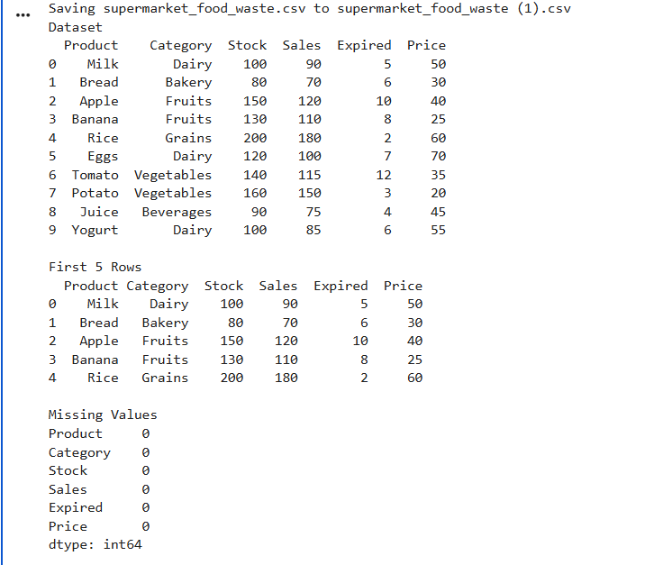
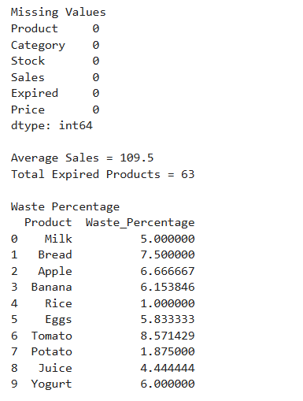

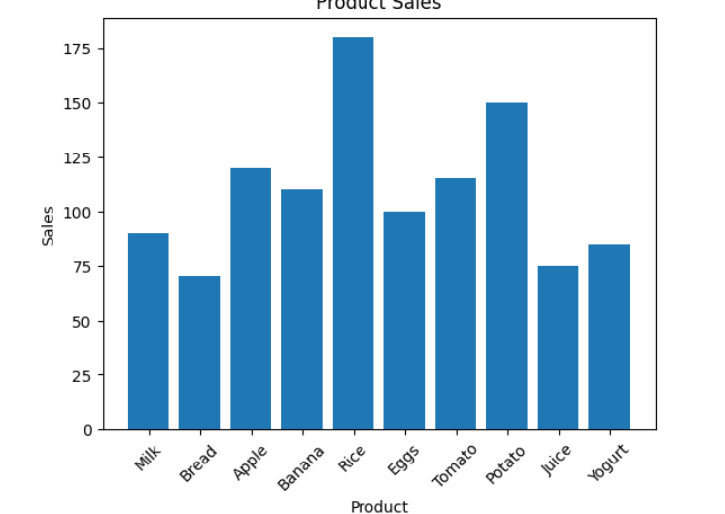
Interpretation:
The graph shows the sales quantity of each product.
From the graph:
- Rice has the highest sales.
- Potato also has high sales.
- Bread has comparatively lower sales.
This information helps supermarkets understand customer demand and maintain appropriate inventory levels.

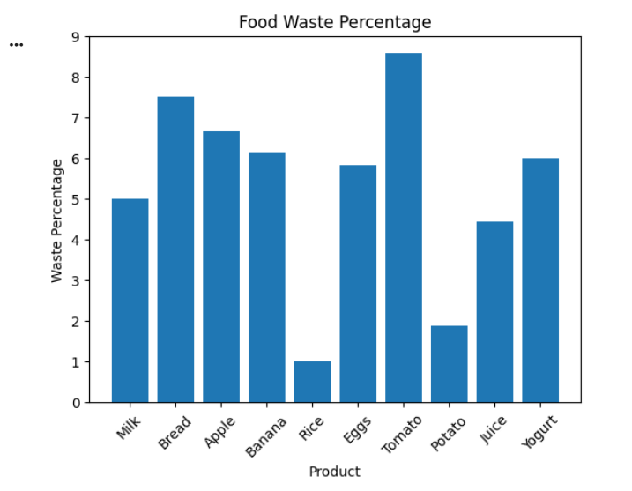
Interpretation:
The graph represents the percentage of products wasted.
From the graph:
- Tomato has the highest waste percentage.
- Bread also has relatively higher wastage.
- Rice has the lowest waste percentage.
Machine Learning can use this information to recommend better stocking strategies and reduce food wastage.
10. Innovation and SDG Mapping:
Innovation:
Traditional supermarkets rely on manual estimation to decide how much stock to purchase. This often leads to overstocking and food wastage.
The proposed solution uses Machine Learning concepts along with data analysis to study historical sales and wastage patterns. By identifying products with high wastage and understanding customer demand, supermarkets can make better inventory decisions.
This data-driven approach improves operational efficiency, reduces losses, and supports sustainable food management.
SDG Mapping:
Related SDG
SDG 2 – Zero Hunger
Project Contribution
The project contributes to SDG 2 by:
- Reducing food wastage.
- Increasing food availability.
- Improving inventory planning.
- Supporting food security.
- Encouraging efficient utilization of food resources.
By minimizing unnecessary food loss, supermarkets can contribute towards achieving the goal of Zero Hunger.
Advantages:
The advantages of the proposed system include:
- Reduces food wastage.
- Improves demand prediction.
- Minimizes inventory losses.
- Saves storage space.
- Increases supermarket profit.
- Supports sustainable food management.
- Enhances decision-making using data analysis.
Limitations:
Although the proposed system has several advantages, it also has some limitations.
- The dataset used is small.
- Prediction accuracy depends on data quality.
- Customer demand may change unexpectedly.
- Seasonal changes may affect prediction accuracy.
- Requires regular updating of sales data.
Practical Applications:
The proposed system can be applied in:
- Supermarkets
- Grocery stores
- Retail chains
- Food warehouses
- Hypermarkets
- Online grocery delivery companies
- Food distribution centers

Recommendations:
To further improve the system, the following recommendations can be considered:
- Use larger real-world datasets.
- Apply advanced Machine Learning algorithms.
- Include seasonal demand analysis.
- Monitor inventory regularly.
- Offer discounts on products nearing expiry.
- Update prediction models frequently using new sales data.

Conclusion:
Food wastage is a major issue affecting both businesses and society. This project demonstrates how Machine Learning and data analysis can help supermarkets reduce food wastage by understanding sales trends and inventory data.
Using NumPy, Pandas, and Matplotlib, the supermarket dataset was analyzed to calculate average sales, total expired products, and food waste percentage. The visualizations clearly identified products with higher wastage.
By using Machine Learning for demand prediction, supermarkets can stock products more efficiently, reduce expired items, improve profitability, and support SDG 2 – Zero Hunger by making better use of available food resources.

